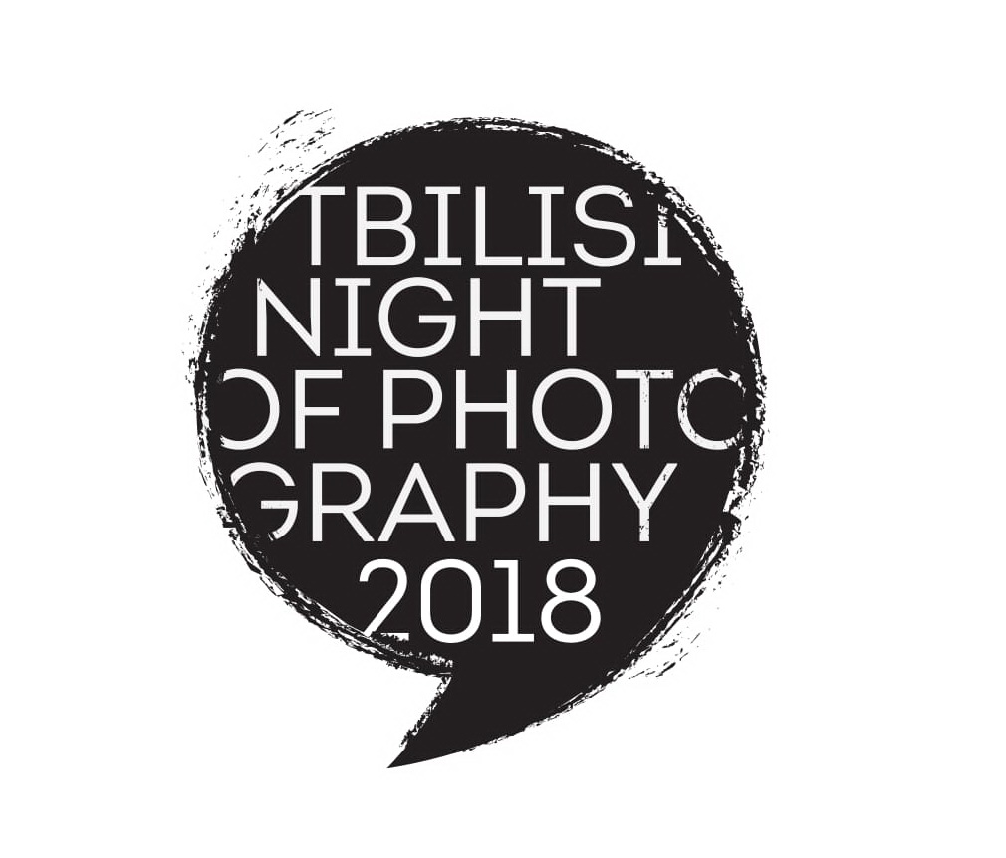

NIGHT OF PHOTOGRAPHY 2018
On Saturday, September 15th

TBILISI PHOTO FESTIVAL 2018

ROADMAP

The final selection of the images should be submitted no later than July 15th, 2018
Credits, texts and other mentions must appear in English

The elements for submission of the photo projects:

- Selection of up to 30 images representing the photo project/series/body of work on announced theme
- Image size: no smaller than 768x1024 pxl
- Project/series /body of works introduction text in English (or Georgian for Georgians ). Please make sure to have it in English so we can make a Georgian translation to make a sub-title. Introduction text - maximum 70 words.

- suggested Music for the slideshow.

Every project must be accompanied by an .rtf or .pdf text file containing:

- the name of the artist, magazine, collective or agency
- the names of the subjects and photographers in order of appearance in the slide show
- musical credits

